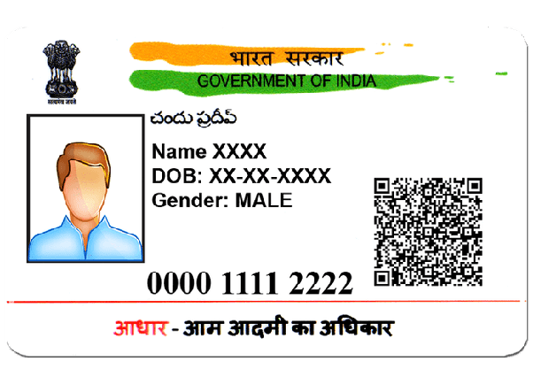



NAME – XXXXXXXX

DOB – XX-XX-XX

GENDER - FEMALE

0011 1111 2222 